Published On: Tue, Nov 3rd, 2015
Promotion | By Manisha Sen

I-T Dept Employees Suspend 2-Month Long Agitation After Finmin Assurance
New Delhi: Two major employees’ associations of the Income Tax Department today said they would suspend their two-month long agitation from tomorrow after the Finance Ministry assured them of resolving their demands by March next year.
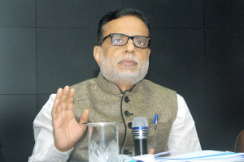
Revenue Secretary Hasmukh Adhia assured Income Tax employees that the CBDT would take immediate efforts to fill up vacant posts in the cadre of Assistant Commissioner of Income Tax.
The two groups – Income Tax Employees Federation (ITEF) and Income Tax Gazetted Officers’ Association (ITGOA) – represent about 97 per cent of the department’s workforce and comprise about 50,000 employees.
“A meeting was convened by the Revenue Secretary Hasmukh Adhia with the members of joint council action today and it was assured that the CBDT would take immediate efforts to fill up vacant posts in the cadre of Assistant Commissioner of Income Tax.
“The other issues were also discussed in the meeting and the CBDT was directed to initiate process for redressing the issues. The Revenue Secretary expressed concern over the issue of stagnation in the cadre of Income Tax Officer and assured to reduce the same within March 31, 2016,” the two associations said in a late evening statement.
“In view of assurances given by the Revenue Secretary, the joint council has decided to suspend the agitation from November 4 in order to create an amicable atmosphere to enable the CBDT to fulfil the directions issued by the Revenue Secretary,” the statement said.
The associations have begun their agitation, including non-cooperation in the crucial search and raid operations, in September in support of their demands of timely promotions and providing better infrastructure for their cadres to work.
PTI

