MODEL STRIKE NOTICE
(To be typed in the letter head of the concerned Circle of ITEF)

Dated: 09thJune 2016

To

The Pr.Chief Commissioner of Income Tax (CCA),

Subject: STRIKE NOTICE
Sir,

As decided by the National Joint Council of Action (NJCA) of Central Govt. Employees and endorsed by the Confederation of Central Govt. Employees & Workers as also by the Income Tax Employees Federation, I hereby submit a copy of the strike notice served on the Chairman, CBDT, New Delhi intimating him that the employees of Income Tax Department who are members of the Income tax employees Federation will go on Indefinite strike from 11th July, 2016. The Charter of demands in pursuance of which the employees will embark upon the Indefinite Strike action is enclosed.

Thanking you,

Yours faithfully,

( )
Circle General Secretary

  INCOME TAX EMPLOYEES FEDERATION  President: Ashok Kr. Kanojia  090138 50795 | Since 1953 | CENTRAL HEADQUARTERS  A2/95, Manishinath Bhawan,  Rajouri Garden, NEW DELHI-110027  Tel.011-2510 5324; 2593 7462  Website: www.itefcentralhq.org  Email. itefcentral@gmail.com  Secretary General: Rupak Sarkar  089021 98000

No. ITEF/Strike/2016 Dated: 09thJune 2016

To

The Chairman,
Central Board of Direct Taxes,
North Block,
NEW DELHI - 110001

Subject: STRIKE NOTICE
Sir,

As decided by the National Joint Council of Action (NJCA) of Central Govt. Employees and endorsed by the Confederation of Central Govt. Employees & Workers, to which the Income Tax Employees Federation is affiliated, I have been directed to give notice that the employees of Income Tax Department who are members of the ITEF will go on Indefinite strike from 11th July, 2016. The Charter of demands in pursuance of which the employees will embark upon the Indefinite Strike action is enclosed.

Thanking you,

Yours faithfully,

(Rupak Sarkar)
Secretary General

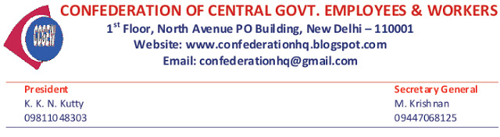
No. Confdn/Strike/2016 Dated: 09thJune 2016

To

The Cabinet Secretary,
Cabinet Secretariat,
Government of India,
Rastrapathi Bhawan,
NEW DELHI - 110004

Sir,

This is to give notice that the employees who are members of the affiliated organisations of the Confederation of Central Government Employees and Workers will go on indefinite strike from 11th July, 2016. The Charter of demands in pursuance of which the employees will embark upon the Indefinite Strike action is enclosed.

Thanking you,

Yours faithfully,

M. Krishnan,
Secretary General

