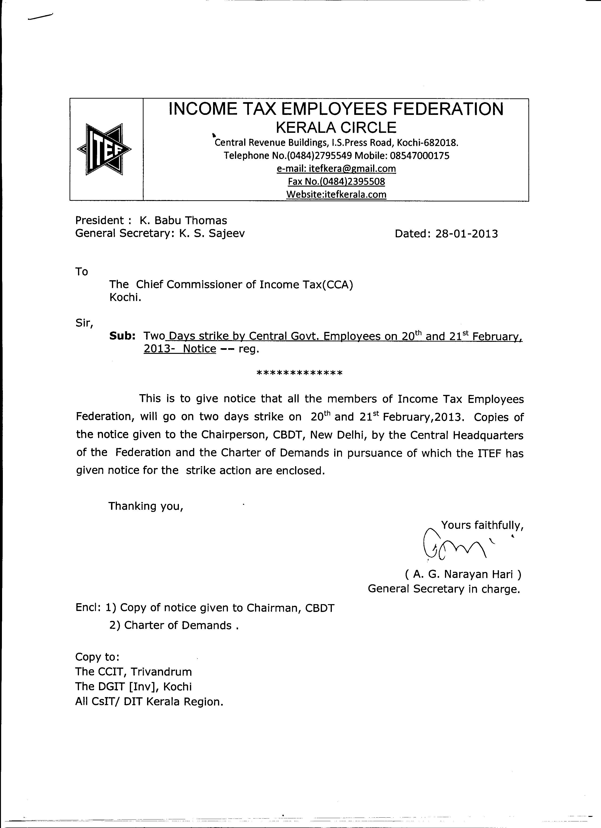

INCOME TAX EMPLOYEES FEDERATION,
Manishinath Bhawan, A/2/95,
Rajouri Garden, New Delhi 110 027
Telephone No : 2510 5324 – 098682 77455
e-mail : itefcentral@gmail.com<> Website: itefcentralhq.org

President: Ashok B Salunkhe Secretary General: KP Rajagopal

No. N-1/12-15 Dated: 22nd January, 2013

To
The Chairperson,
Central Board of Direct Taxes,
North Block,
New Delhi- 110 001.

Madam,

Sub: Two Days strike by Central Govt. Employees on 20th and 21st February,
2013- Notice –

This is to give notice that all the members of Income Tax Employees Federation, which is affiliated to the Confederation of Central Government Employees and Workers, will go on two days strike on 20th and 21st February, 2013. The Charter of Demands in pursuance of which the Confederation has given notice to the Cabinet Secretary for the strike action is enclosed.
Thanking you,
Yours faithfully,
Sd/-
(KP Rajagopal)
Secretary General
Enclosure as above.

CONFEDERATION OFCENTRAL GOVERNMENT
EMPLOYEES AND WORKERS.
Chq:Manishinath Bhawan,
A/2/95 Rajouri Garden, New Delhi.110 027
E mail: confederation06@yahoo.co.in
Website:confederationhq.blogspot.com.

No. Conf. 22/2013 Dated: 19th January, 2013.
To
The Cabinet Secretary,
Cabiner Secretariat,
Government of India,
Rastrapathi Bhawan,
NEW DELHI.

Dear Sir,
This is to give notice that the employees who are members of the affiliated organisations of the Confederation of Central Government Employees and Workers will go on two days strike on 20th and 21st February, 2013. The Charter of demands in pursuance of which the employees will embark upon the one day strike action is enclosed.

Thanking you,
Yours faithfully,
Sd/-
K.K.N.Kutty,
Secretary General,

Encl: Charter of demands

CHARTER OF DEMANDS
PART – I
1. Revise the wages of the Central Government employees including Gramin Dak Sewaks with effect from 1.1.2011 and every five years thereafter by setting up the 7thCPC.
2. Merge DA with Pay for all purposes with effect from 1.1.2011 including for Gramin Dak Sewaks.
3. Remove restriction imposed on compassionate appointments and the discrimination on such appointments between the Railway workers and other Central Government Employees.
4.[a] Departmentalise all Gramin Dak Sweaks and grant them all benefits of regular employees; End Bonus discrimination and enhance bonus ceiling to 3500/-; Withdraw open market recruitment in Postman / MTS cadre; Revise cash handling norms; Grant full protection of TRCA; Grant Time Bound Promotion and Medical Reimbursement facility etc.
[b] Regularise the daily rated, contingent, casual workers and introduce a permanent scheme for periodical regularization. Pending regularization, provide them with pro-rata salary at 6th CPC rates.
5.(a) Revive the functioning of the JCM. Convene the meeting of the Departmental Councils in all Ministries/Departments. Settle the anomalies raised in the National Anomaly Committee as also in the Departmental Anomaly Committees. Hold National Council meetings as specified in the JCM constitution. (b) Remove the anomalies in the MACP Scheme.(c) Grant recognition to all Associations/Federations, which have complied with the formalities and conditions stipulated in the CCS(RSA) Rules.
6. Fill up all vacant posts and creates posts n functional requirements
7. Stop downsizing outsourcing, contractorization, corporatization and privatization of Government functions.
8. Stop Price rise; Strengthen the PDS.
9.(a) Stop the proposal to introduce the productivity linked wage system; (b) discard the performance related pay structure; (c) introduce PLB in all Departments; (d) remove the ceiling on emoluments for bonus computation.
10. Revise the OTA, Night duty allowance and clothing rates.
11. Implement all arbitration awards.
12. Make the right to strike a legal and fundamental right of the Government employees on par with the other section of the working class.
13. Grant Five promotions to all employees as is provided for in the case of Group-A services.
14.(a) Withdraw the PFRDA Bill. (b) Rescind the decision to allow FDI in pension sector;(c) Scrap the new contributory pension scheme (d) Extend the existing statutory defined pension scheme to all Central Govt. employees irrespective of their date of entry in Government service.
15. Vacate all Trade Union victimisation, and more specifically in the Indian Audit and Accounts Department.
PART-II
- Take concrete measures to contain Price rise.
- Take concrete measures for linkage of employment protection with the concession / incentive package offered to the entrepreneurs.
- Ensure strict enforcement of all basic labour laws without any exception or exemption and stringent punitive measures for violation of labour laws.
- Universal social security cover for the unorganised sector workers without any restriction and creation of a National Social Security Fund with adequate resources in line with the recommendation of NCEUS and Parliamentary Standing Committee on Labour.
- Stoppage of disinvestment in Central and State PSUs.
- No Contractorisation of work permanent/perennial nature and payment of wages and benefits to the contract workers at the same rate as available to the regular workers of the industry / establishment.
- Amendment of Minimum Wages Act to ensure universal coverage irrespective of the schedules and fixation of statutory minimum wage at not less than Rs.10,000/-.
- Remove all ceilings on payment and eligibility of Bonus, Provident Fund; Increase the quantum of gratuity.
- Assured statutory Pension for all.
- Ensure Compulsory registration of trade unions within a period of 45 days and immediate ratification of the ILO Conventions Nos.87 and 98.

