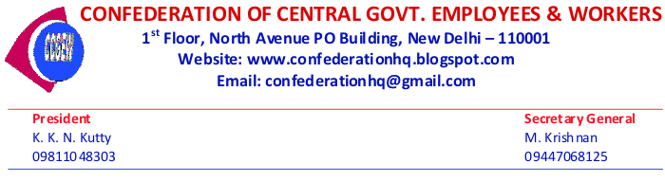
Dear Comrades,

National Secretariat of the Confederation of Central Govt Employees & Workers held on 27-11-15 at New Delhi after detailed deliberations on the recommendations of the 7th Central Pay Commission (CPC) has decided as follows :

1.The National Secretariat has come to the unanimous conclusion that many of the recommendations of the 7thCPC are most retrograde and require to be modified before implementation by the Government, especially the faulty and depressed minimum wage arrived at by the 7th CPC and the fitment formula. Some of the recommendations such as abolition of certain allowances etc., are to be rejected.

2. The National Secretariat is of the firm opinion that a united struggle of entire Central Govt Employees including Railways, Defence and Confederation under the banner of National Joint Council of Action (NJCA) can only compel the Government to modify or reject the retrograde recommendations of the 7th CPC and hence it is decided to further strengthen the unity.

3. The National Secretariat further resolved that the form of the united struggle of NJCA should be an indefinite strike, within a time frame, as Govt is moving fast to implement the recommendations. Negotiation with the Government should precede declaration of indefinite strike and intensive campaign among the employees and mobilization, to create sanction behind the demands.

4. In case the requisite movement is not coming about for any reason, Confederation National Secretariat will meet and chalk out its own independent action.

5. Regarding the sector-wise issues relating to the employees of each department, the affiliated organizations of the Confederation in those departments shall take initiative for uniting all like-minded Federations/Associations/Unions in their department and shall organize agitational programmes on departmental specific demands.

6. The National Secretariat decided to insist that the charter of demands of the NJCA and Confederation should include the demands of Gramin Dak Sevaks, Casual/Contract labourers, filling up of vacancies and scraping the New Contributory Pension Scheme.

7. All affiliated organizations of Confederation are requested to intimate by e-mail to the Confederation CHQ (confederationhq@gmail.com or mkrishnan6854@gmail.com) on the required modifications or additions / deletions in the common recommendations (not department-specific) of the 7th Pay Commission on or before 05-12-2015.

8. Available Secretariat members of the Confederation will meet on 07-12-2015 at New Delhi and finalize the common demands to be included in the charter of demands of NJCA. (NJCA meeting is being held at JCM National Council, Staff-side office on 08-12-2015 to finalize the charter of demands and the further course of action).

9. The National Secretariat congratulated all the Central Govt Employees who made the 27th November 2015 ‘All India Protest Day’ at the call of NJCA, a grand success all over the country by wearing ‘black badges’ and participating in protest demonstrations.

Other Decisions:
1. Next All India Workshop-cum-Trade Union Camp of Confederation will be held at Dehradun (Uttarakhand) before March 2016.

2. The National Secretariat extended full support and solidarity to the proposed agitational programmes of Passport Employees Association including ‘Indefinite hungerfast’.

=M.Krishnan
Secretary General

